|  |  |
| --- | --- |
| **EXPT.NO.2** | **Hadoop Implementation of file management tasks, such as Adding files and directories, retrieving files and Deleting files** |

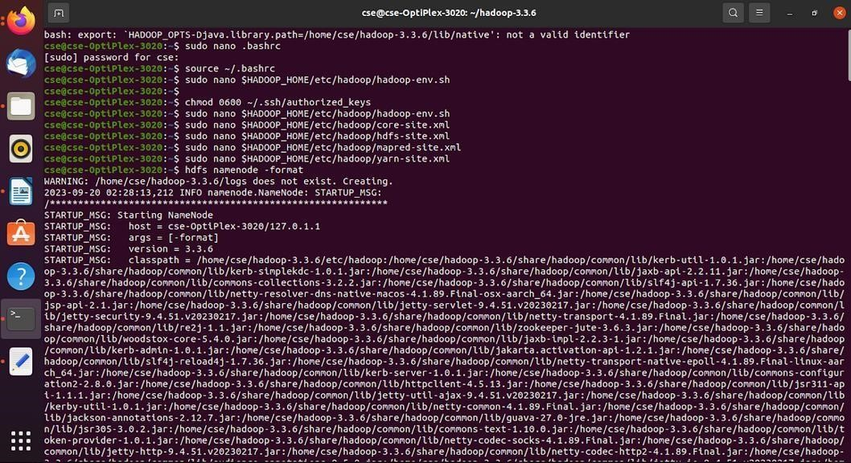

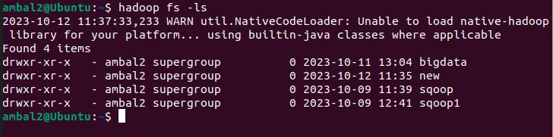

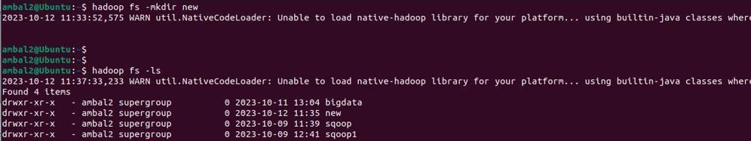

|  |  |
| --- | --- |
| **EXPT.NO.3** | **Implement of Matrix Multiplication with Hadoop Map Reduce** |

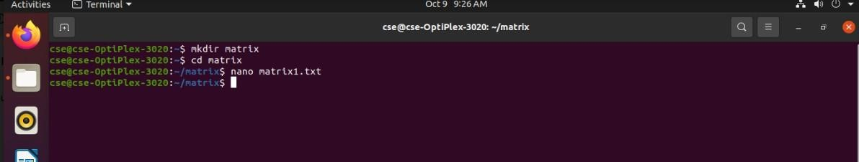





|  |  |
| --- | --- |
| **EXPT.NO.4** | **Run a basic Word Count Map Reduce program to understand Map**  **Reduce Paradigm** |

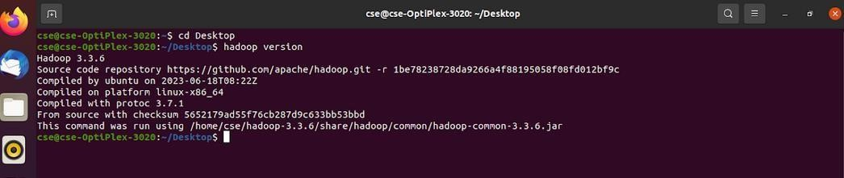

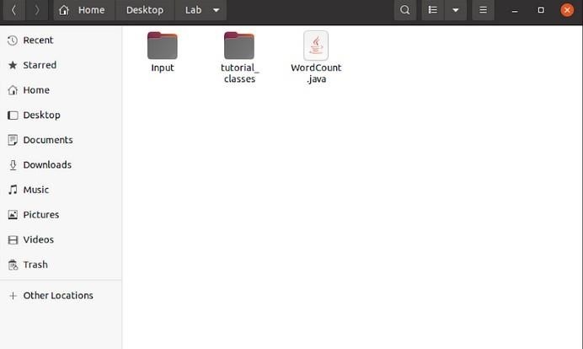

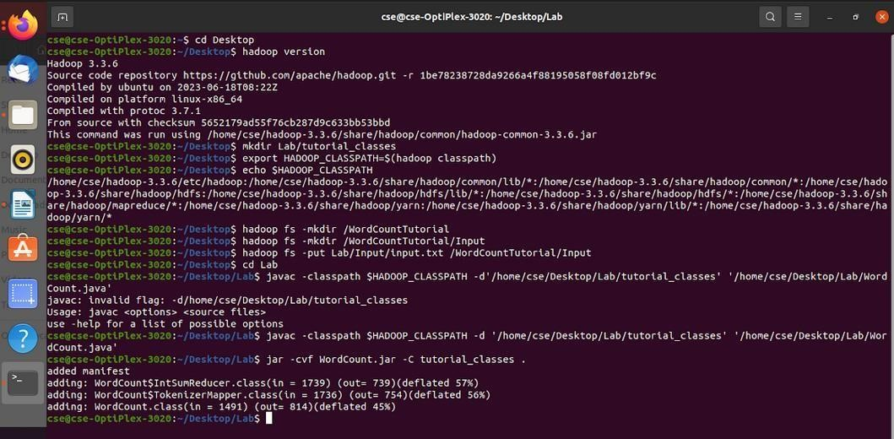

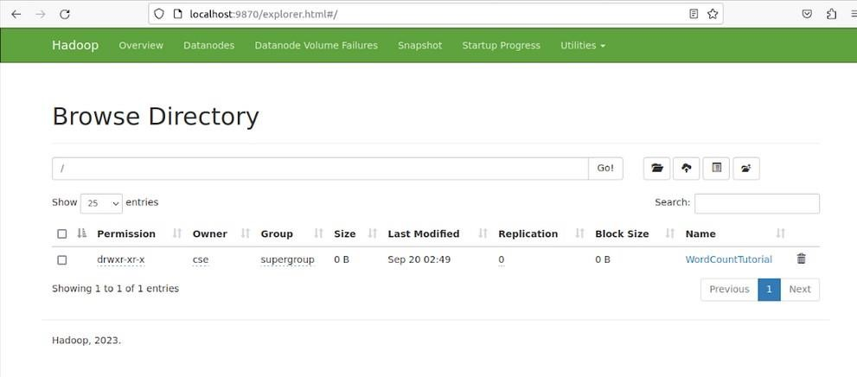

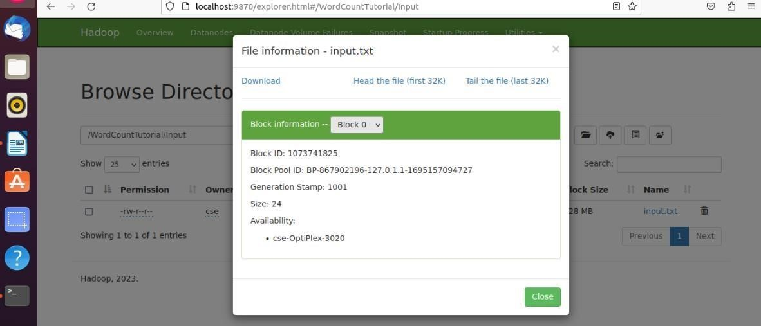

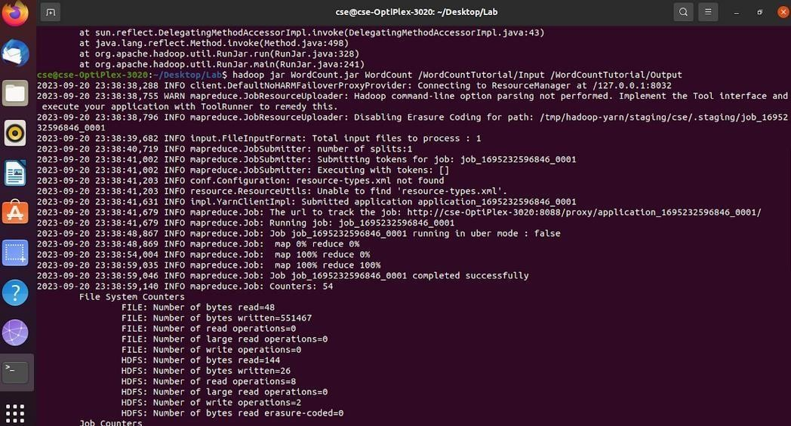

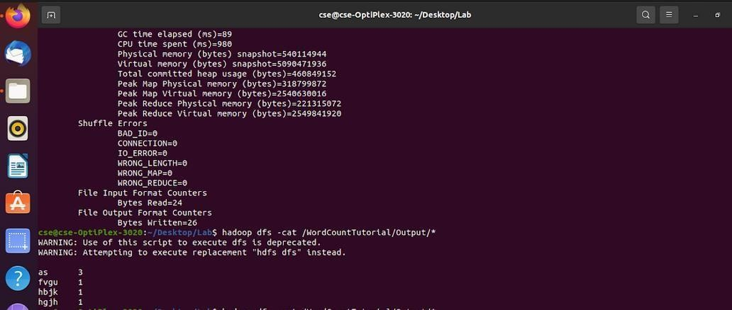



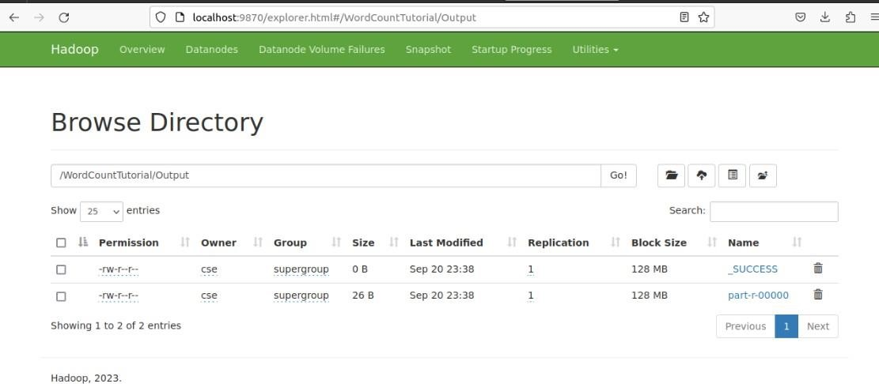

|  |  |
| --- | --- |
| **EXPT.NO.5** | **Installation hive** |

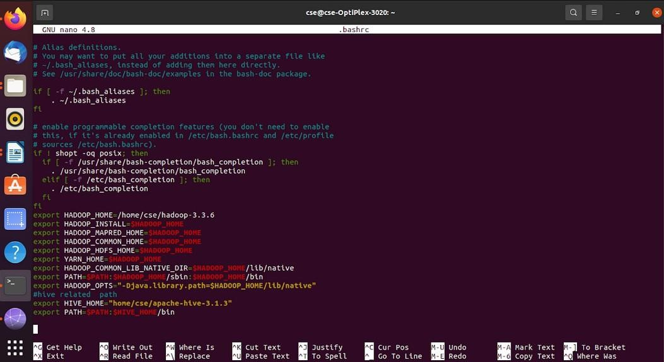

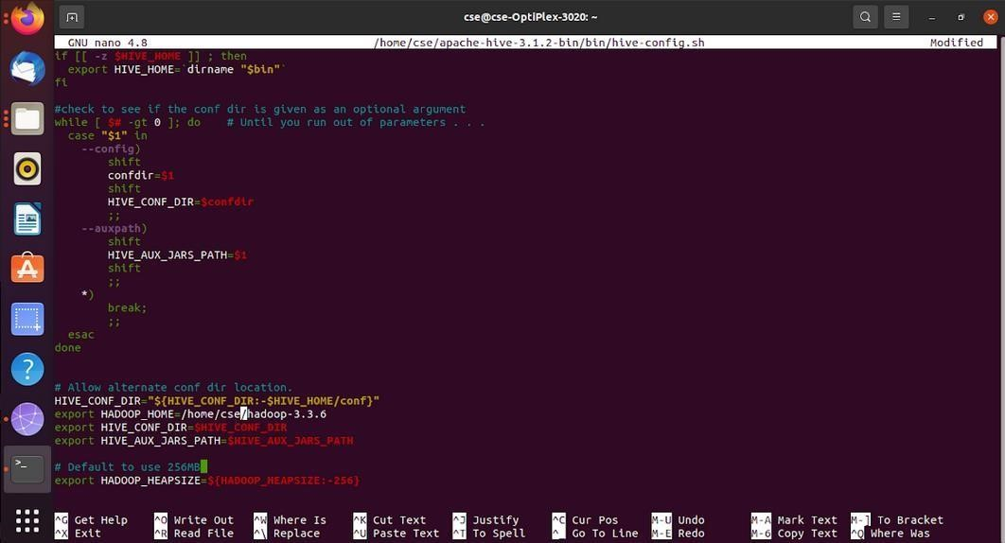

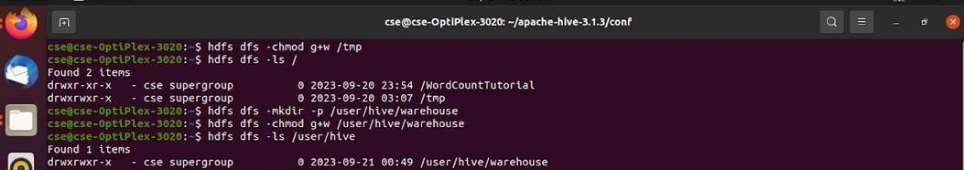

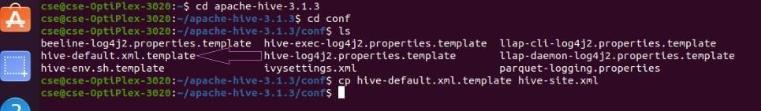

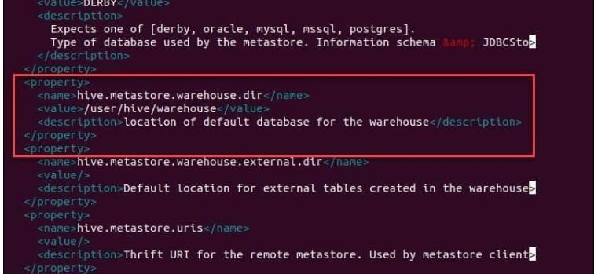

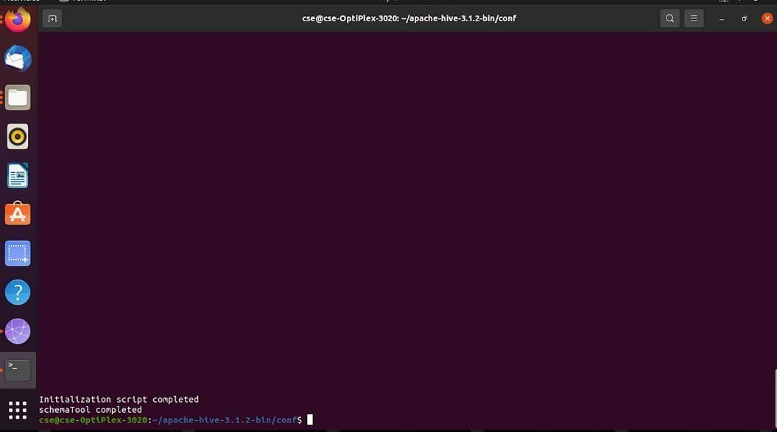

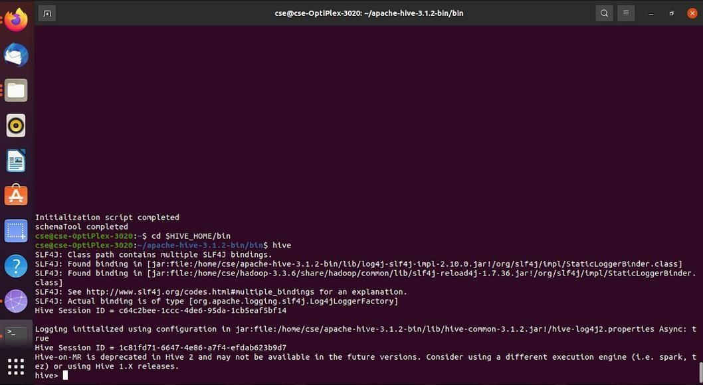

|  |  |
| --- | --- |
| **EXPT.NO.6(a)** | **Installation of HBase, Installing thrift along with Practice examples** |

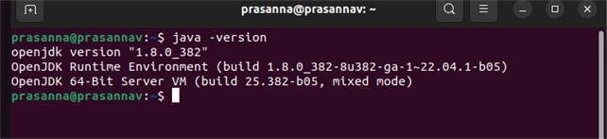

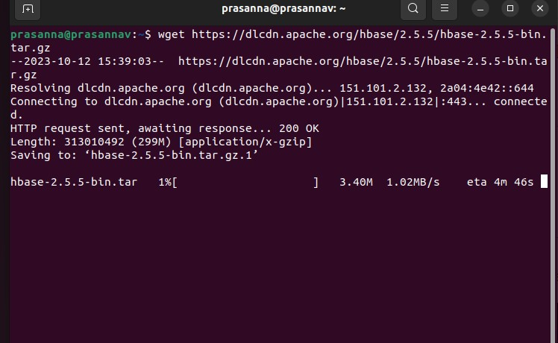

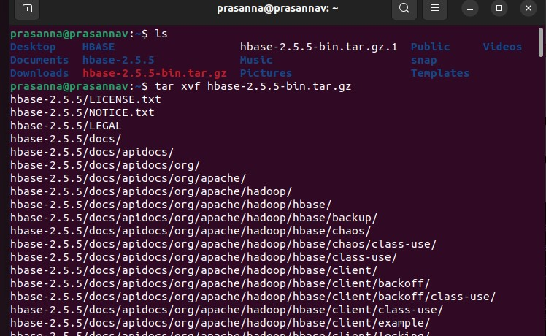

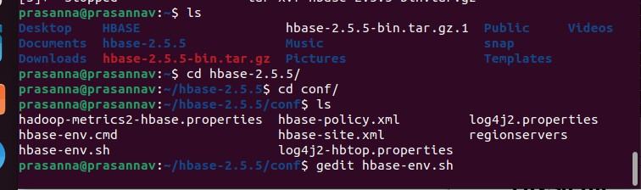

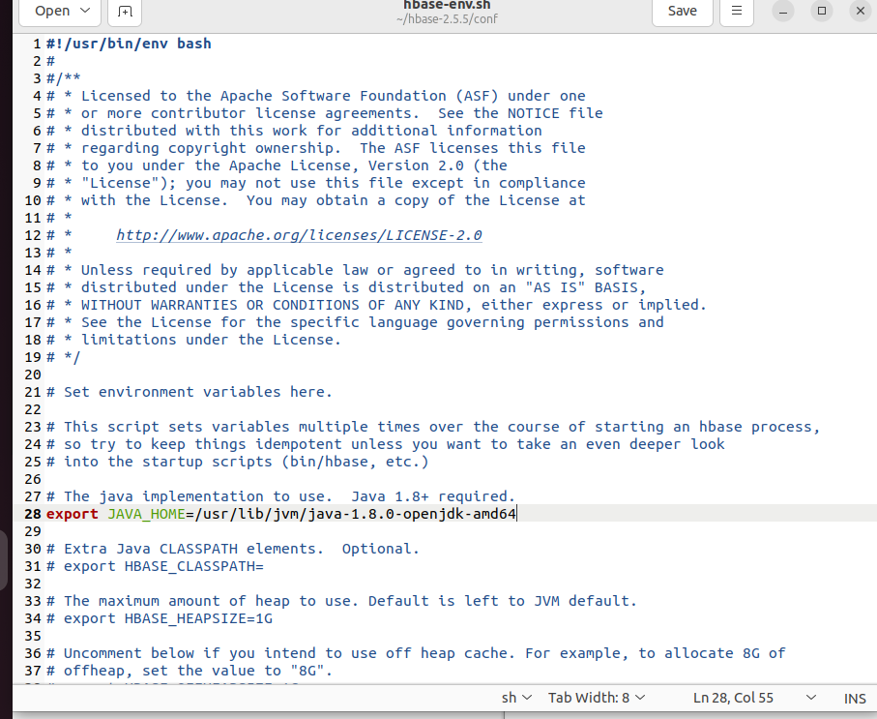

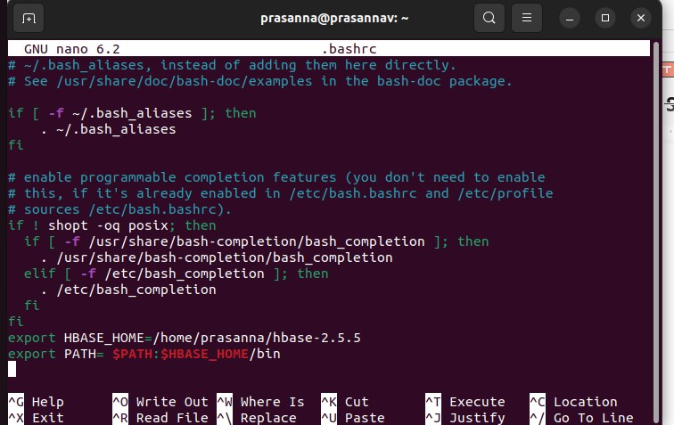





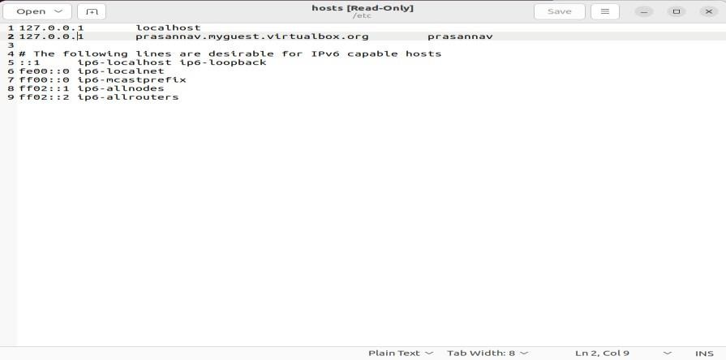

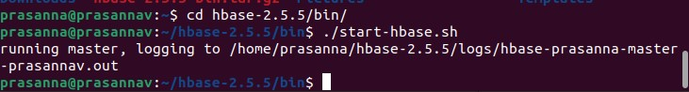

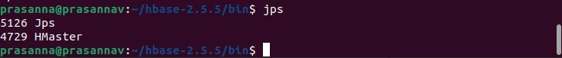

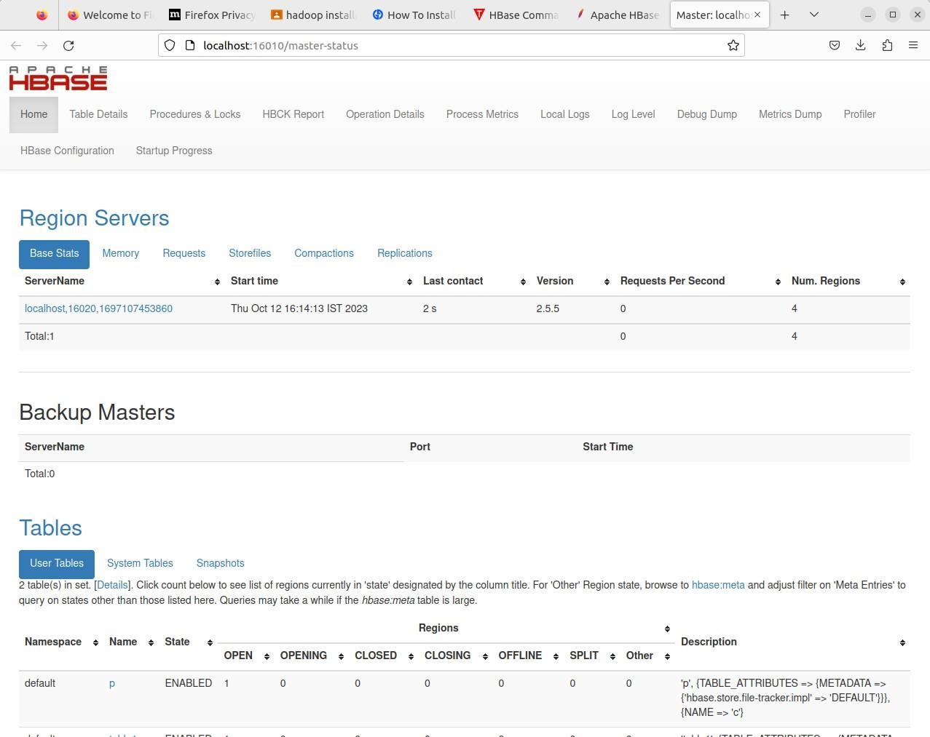

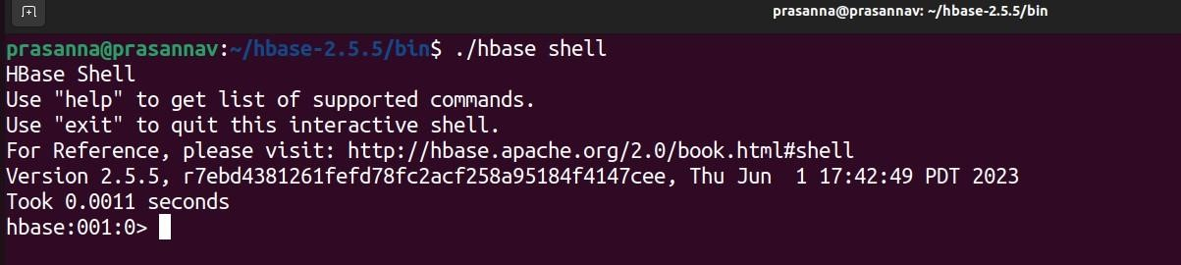

|  |  |
| --- | --- |
| **EXPT.NO.6(b)** | **HBase, Installing thrift along with Practice examples** |

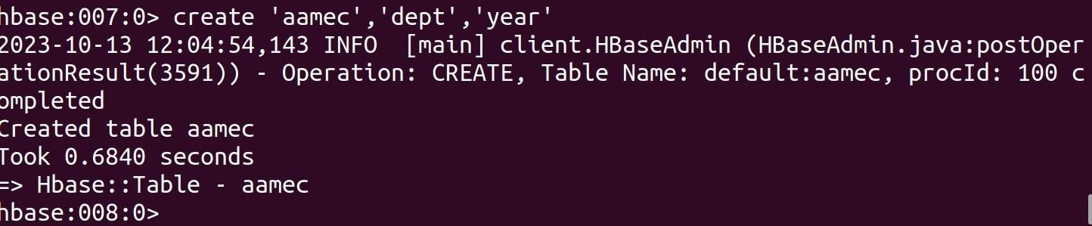

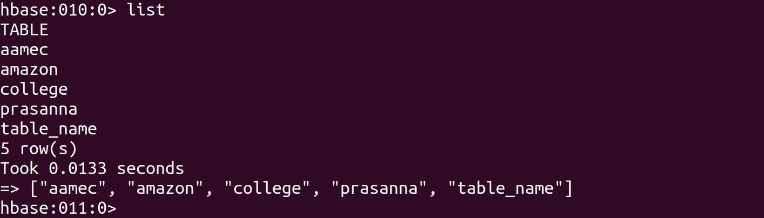

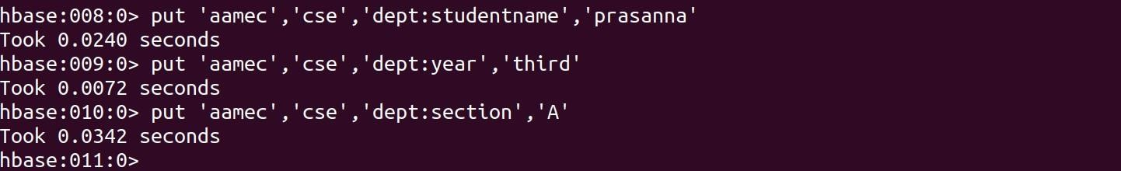

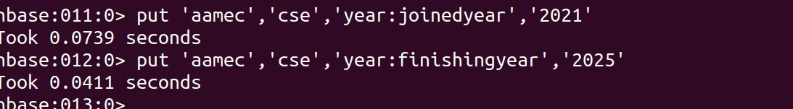

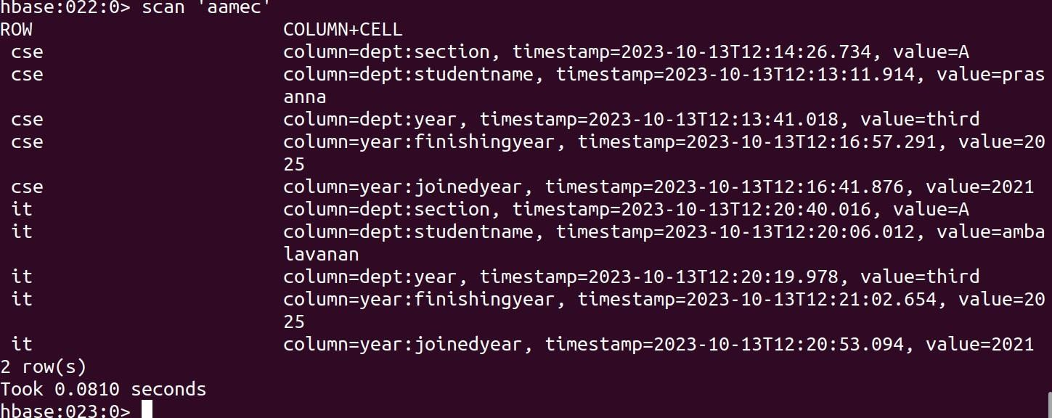

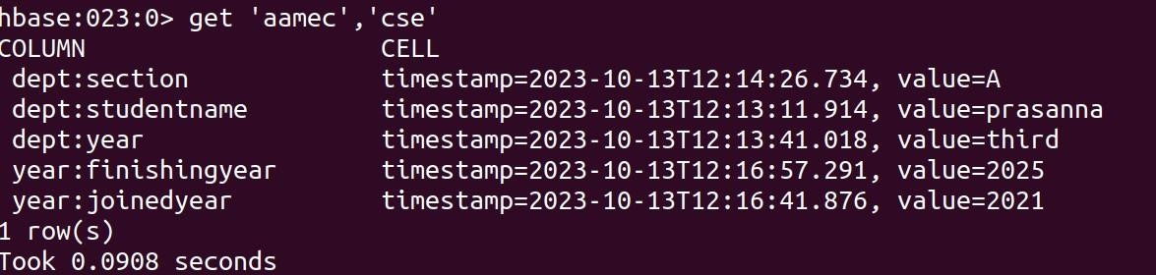



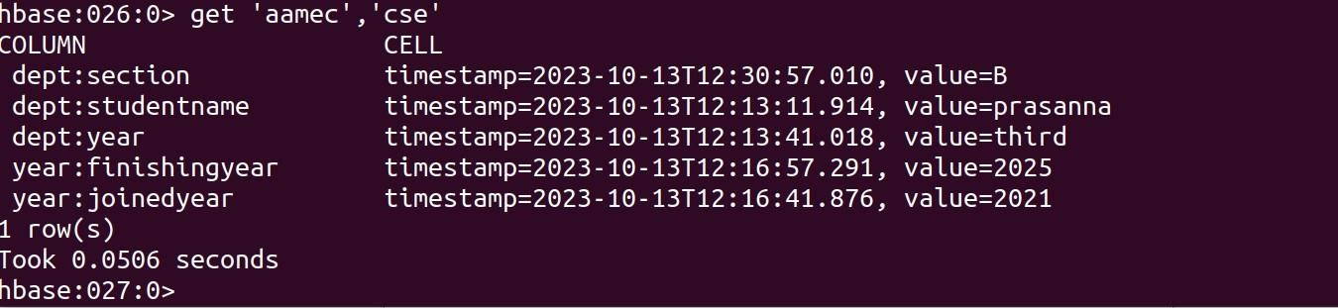

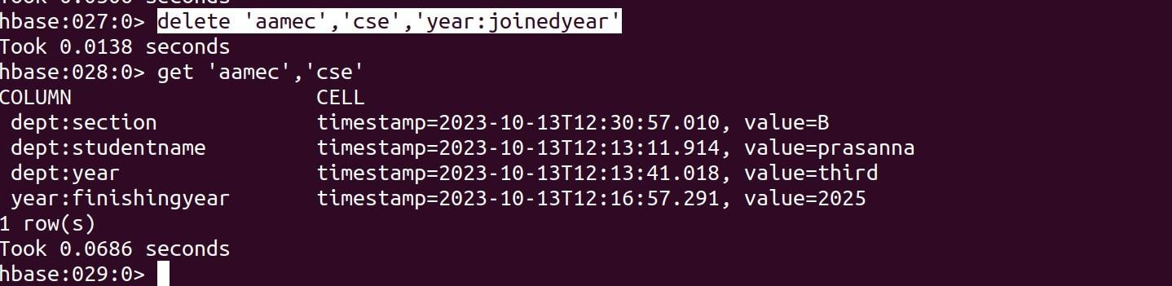

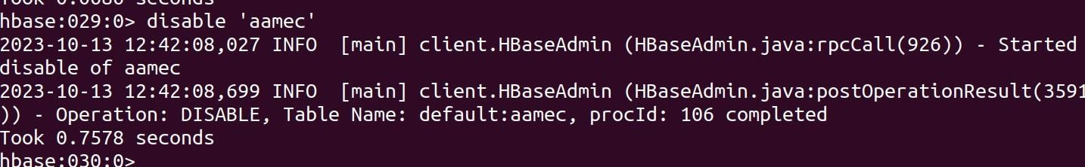

|  |  |
| --- | --- |
| **EXPT.NO.7** | **Practice importing and exporting data from various databases** |

